

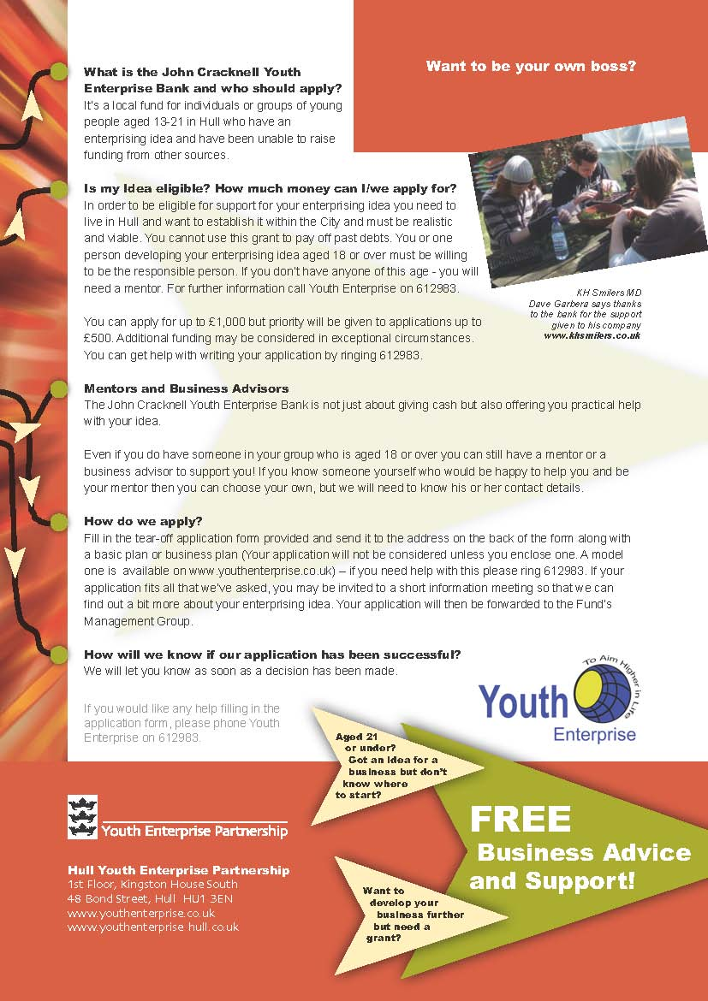

[Insert Business Name Here]

Business Plan/Application Form

Created by: [Insert your name]

Tell us a little bit about your enterprising idea
What do you want to do? Why you think it is needed? Who will it benefit? How many jobs will your enterprising idea create (including yourself)? If none, how can it help you or others to get a job in the future or how can it contribute to improving your local community?

If anyone else is supporting you with your idea, please tell us who they are and in what way they are helping. Please state what other financial support you are getting or applying for.

Total amount of money you would like to apply for?
£

Would you like a mentor or business advisor to help you with your idea?
(You must have a mentor if no one in the group is aged over 18)

YES | NO

Do you have a person in mind to mentor & support you?
(If so, please tell us their name and where we can contact them)

Business name | -
Owner(s) name | -
Home address | -
Post Code | -
Date of Birth | -
Priority Ward/Area  (Adviser to complete) | -
Non Priority Ward/Area  (Adviser to complete) | -
Home telephone number
Mobile telephone number | -
Home E-mail address | -
Submitted to | -
Date | -

Are you or your partner on incapacity benefit | -
Are you or your partner on job seekers allowance | -
Are you or your partner on income support | -
If you are aged under 18 are any of your parents /guardians on incapacity benefit if yes which one | -
If you are aged under 18 are any of your parents /guardians on job seekers allowance if yes which one | -

Please confirm to the young people’s enterprise adviser that you are willing to be contacted about the services provided by the Hull Youth Enterprise Partners and are willing to receive up-to date information via –mail or text on services provided:

Via Home E-Mail | -
Via Text | -
Willing to be part of a Focus Group or act as mentor in the future and or make a donation to the Youth Enterprise Bank. Please state which | -

Contents

Executive Summary 1
Business Details 3
The Business 4
Key personnel 5
SWOT Analysis 6
Premises 7
Plant, machinery and equipment 7
Products and services 8
Pricing 9
Customers 9
Competition 12
Promotion 13
Product pricing and costing 13
Financial information - start-up business 14
Personal survival budget schedule 15
Financial projections 16,14,15
Financial requirements 19
Personal asset statement 20
Cash flow forecast year 1 21
Cash flow forecast year 2 22

If you require this form in an alternative format or have any problems in completing the form, please call the Youth Enterprise Centre on 01482 839479

Description of Business

1 Describe the products you make or sell or the services you provide.

Remember the box will automatically expand to take as much information as you key in.

2 Give details of your business premises.

-

Owner(s) Personal Details

3 Give details of knowledge and experience.

Business Training

4 Give details of any training you have had that gives you the skills or business knowledge which will help you succeed with your idea.

Also give details of any training you intend to take to help you with your business idea.

Your Market

5 Details of market research (attach evidence)

-

Your Market (continued)

6 Who are your customers?

7 Who are your competitors?

Your Market (continued)

8 Describe how / where you plan to sell your products / services and advertise / promote your business. Give details of costs.

9 How / why do you think you will be successful in this market?

Pricing Policy

10 Explain how much money you will charge for your products / services and your total costs.

Sales Analysis

11 Explain how many items / services / jobs you think you will be able to sell over the next 12 months and what your expected income will be.

-

Costs

12 List all the things you will need to buy (such as equipment, materials, stock and services) in order to get your business running.

Description | Cost £
Total | £

List the things you already own and plan to use in your business.

Description | Value £

Personal Survival Income

14 Detail below your minimum personal expenditure and any income.
(Do not include any business costs)

DESCRIPTION |  |  | COST £
ESTIMATED MONTHLY EXPENDITURE
Mortgage
Rent
Business rates or Council tax
Water rates
Gas, electricity & oil
All personal & property insurance
Food, housekeeping (including board)
Clothing
Telephone
Hire charges (TV, video etc.)
Entertainment (meals & drinks)
Subscriptions (associations, journals, etc.)
Car tax & insurance
Car service maintenance
Children’s expenditure & presents
Savings plan
Credit card/loan repayments
Other (please state)
Contingencies
SUB-TOTAL - EXPENDITURE |  | (a)
ESTIMATED MONTHLY INCOME
Income from family/partner (total)
Government benefits
(e.g. Working Tax credits, Incapacity Benefit, Income Support and or Job Seekers Allowance)
Other income (please state)
SUB-TOTAL – INCOME | (b)
TOTAL SURVIVAL INCOME REQUIRED IN THE YEAR (a) LESS (b)
If your estimated income (b) is greater than your estimated expenditure (a), you should decide how much money you could invest in your business.

Cash flow Forecast for 12 month Period Ending: Business Name:

 | Pre-start Period | Month 1 | Month 2 | Month 3 | Month 4 | Month 5 | Month 6 | Month 7 | Month 8 | Month 9 | Month 10 | Month 11 | Month 12 | TOTAL
CASH IN
Funding from Youth Enterprise Bank or other Youth Enterprise Bank partners e.g. Acorn Fund
Funding from other sources
Own funds
Cash from customers
Other income
TOTAL CASH IN
CASH OUT
Capital expenditure
Purchase of tools
Purchase of materials / stock
Employee costs (Wages / NIC)
Rent / rates
Heat / light / water
Phone – office / mobile
Postage
Printing & stationary
Motor insurance / tax
Motor repairs / maintenance
Petrol / diesel
Other travel costs
Business repairs / maintenance
Advertising and promotion
Legal & professional
IT costs
Other costs
Loan repayments – Youth Enterprise Bank or mainstream banks or Acorn Fund
Loan repayments - others
Loan interest
Bank charges
Personal drawings
TOTAL CASH OUT
CASH IN less CASH OUT
Opening balance / (deficit)
Closing balance / (deficit)

